December Newsletter

COVID Reminder
Please can we ask that if your child displays symptoms at home, that you do not mask these symptoms with Calpol and follow the guidelines set out by the government. We are all working super hard to keep nursery as safe as possible and also ensure we can keep our staff and your children in nursery…please help us by following the policies and guidelines

Funded Childcare Hours
If your child turns 2 on or before December 31st, they may be eligible for 15 hours funded childcare. To check eligibility, click on the link below. If you are eligible please forward the confirmation email to us prior to January term.
https://www.lancashire.gov.uk/children-education-families/early-years-childcare-and-family-support/paying-for-childcare/funded-childcare-for-2-year-olds/
If your child turns 3 on or before December 31st, they may be eligible for 30 hours funded childcare. To check eligibility, click on the link below. If you are eligible please forward your 11-digit code along with your DOB and NI number to us prior to the January term.
https://www.childcarechoices.gov.uk/
Any questions just ask Auntie Karli

We are busy getting all festive in nursery. Here’s a lowdown on the Christmas fun to come……

Christmas Jumper Day
Join us in your festive ‘get up’ on Friday 11th December to raise some pennies for Save The Children. £1 donation recommended.
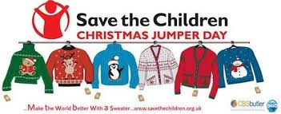

Christmas Party Days
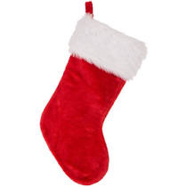
Our nursery Christmas Party will be held on Wednesday 16th December. Dress for a party, enjoy some games and yummy food and lets PARRRTY!!!! Santa will also be visiting, dropping of sacks of presents for the children at each room’s door……we still need some Christmas Magic for our beautiful little ones.
Our Out of School Club party will be on Friday 18th December.

Christmas Closure Days
Nursery will be closed on the 24th December, 25th December, 28th December (in-lieu of Boxing Day), 31st December and 1st January.
To allow us to arrange staffing and ‘bubbles’ for the 29th and 30th of December and hopefully allow as many staff as possible to have time off over the Christmas period, we would kindly ask if you can confirm if your child will be attending.

Primary School Admissions
Reminder that admissions for children due to start primary school in September 2021 are now open and can be accessed by the Lancashire County Council website. The closing date for applications is January 15th 2021.

Weather appropriate clothing
It’s getting chilly outdoors but there is still lots of fun to be had out in our amazing new outdoor space. Please ensure your child comes equipped to be outdoors in all weathers including hats, scarves, gloves, wellies and a nice warm winter coat.
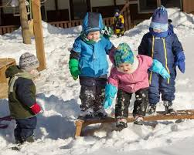

Spare Clothes
Sometimes we get messy when painting, wet when enjoying water play and sometimes we have accidents. Although we do have some nursery spares, our stock is limited so please ensure you provide spares for your child so we can change them when needed and keep them comfortable. These can be kept on their named pegs on the corridors. If your child is sent home in nursery spares please ensure you return them so we don’t run out.

Nappies & Wipes
Please ensure your child is well stocked with nappies and wipes. Although we do have nursery spares, this stock is limited and will be replaced when you bring your child’s in. If we are repeatedly using nursery stock for your child and these are not replaced there will be charge to your invoice at 50p per nappy.

Staff Incentive Box

Our ‘Staff Member of the Month’ for November is……………Auntie Alisa.
For the parents that don’t know we have a monthly prize for our staff member of the month, which is now back up and running. You can contribute to this by telling a member of staff at drop off and pick up if you feel a member of staff should be recognised for anything fabulous, they have done. The staff also do this between themselves and the winner is the staff member with the most positive comments.

General Reminders
- Please ensure you lock ALL gates, both inside and outside of nursery to avoid any escapee children.
- Sickness and diarrhoea:
The Public Health guidelines state that the recommended incubation period is 48 hours from the last bout. Nursery policy states children will be sent home after 3 bouts of diarrhoea or 1 bout of sickness.
Please, please, please don’t hold this against us. We do understand it can be difficult, especially for working parents but it is our duty of care to follow these guidelines.
- Please note invoices are done a month in advance (generally in the last week of the previous month) and are located in individual room boxes on the shelf in the foyer. Payment is to be made no later than the 15th unless prior arrangements have been made in the office.

