November Newsletter

We hope you are all well in these crazy times. You will all be aware we are going into yet another national lockdown as of Thursday but thankfully this time nursery will not be affected. Fingers crossed it stays this way. We have sent out an updated version of our COVID policy on ParentMail this week for you to have a read of. Any questions please give us a call.
Please can we ask that if your child displays symptoms at home, that you do not mask these symptoms with Calpol and follow the guidelines set out by the government. We are all working super hard to keep nursery as safe as possible and also ensure we can keep our staff and your children in nursery…please help us by following the policies and guidelines

Pumpkin Competition
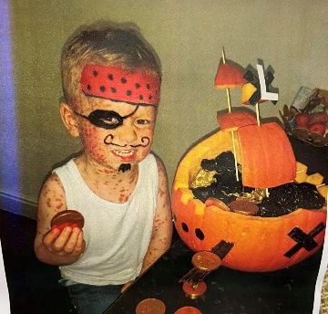
We had lots of fabulous entries into our 2020 Pumpkin Competition but there can only be one winner………decided by yourselves on our Facebook page, the winner is:
LUCAS with his wonderful Pumpkin Pirate Ship

Primary School Admissions
Reminder that admissions for children due to start primary school in September 2021 are now open and can be accessed by the Lancashire County Council website. The closing date for applications is January 15th 2021.

Children In Need
This year’s Children in Need appeal will be on 13th November. This year we won’t be able to hold our normally successful bake sale so we have decided on a crazy hair and spotty day……lets have some fun. Come to nursery as crazy and spotty as you like, donate £1 and help this wonderful charity.

Weather appropriate clothing
It’s getting chilly outdoors but there is still lots of fun to be had out there. Please ensure your child comes equipped to be outdoors in all weathers including hats, scarves, gloves, wellies and a nice warm winter coat.

Spare Clothes
Sometimes we get messy when painting, wet when enjoying water play and sometimes we have accidents. Although we do have some nursery spares, our stock is limited so please ensure you provide spares for your child so we can change them when needed and keep them comfortable. These can be kept on their named pegs on the corridors. If your child is sent home in nursery spares please ensure you return them so we don’t run out.

Nappies & Wipes
Please ensure your child is well stocked with nappies and wipes. Although we do have nursery spares, this stock is limited and will be replaced when you bring your child’s in. If we are repeatedly using nursery stock for your child and these are not replaced there will be charge to your invoice at 50p per nappy.

Staff Incentive Box

Our ‘Staff Member of the Month’ for October is……………Auntie Lindsey.
For the parents that don’t know we have a monthly prize for our staff member of the month, which is now back up and running. You can contribute to this by telling a member of staff at drop off and pick up if you feel a member of staff should be recognised for anything fabulous, they have done. The staff also do this between themselves and the winner is the staff member with the most positive comments.

General Reminders
- Please ensure you lock ALL gates, both inside and outside of nursery to avoid any escapee children.
- Sickness and diarrhoea:
The Public Health guidelines state that the recommended incubation period is 48 hours from the last bout. Nursery policy states children will be sent home after 3 bouts of diarrhoea or 1 bout of sickness.
Please, please, please don’t hold this against us. We do understand it can be difficult, especially for working parents but it is our duty of care to follow these guidelines.
- Please note invoices are done a month in advance (generally in the last week of the previous month) and are located in individual room boxes on the shelf in the foyer. Payment is to be made no later than the 15th unless prior arrangements have been made in the office.

