October Newsletter

A belated welcome to all our new children and their families and welcome back to all our children who have been off for soooo long. We have missed you all very much and its lovely to see how all children, new and old, have settled so well.
A big welcome to Auntie Alisa who is our new baby room leader, Auntie Mehvish and Auntie Melissa who are joining our Pre-school team and finally Auntie Shannon who has joined us a an apprentice in her 2nd year at College.

Outdoors
You will have noticed that work on our outdoors has commenced and all going to plan this should be completed by September 16th. It’s super exciting. Auntie Karli can’t wait for a turn on the climbing wall Here’s another look at what’s coming……
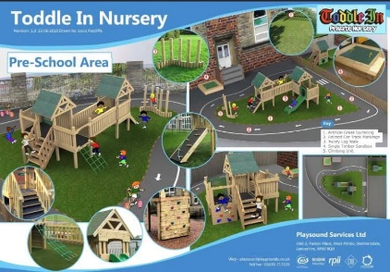
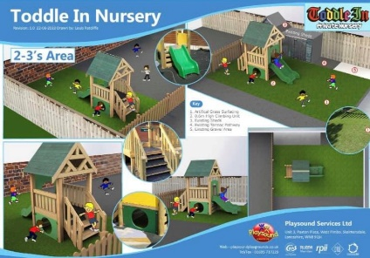
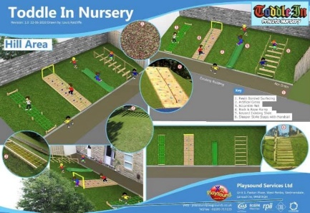

Primary School Admissions
Reminder that admissions for children due to start primary school in September 2021 are now open and can be accessed by the Lancashire County Council website. The closing date for applications is January 15th 2021. In normal times school would send us information regarding open days but due to COVID we are pretty sure this will be done in a different way. If we hear anything about the changes and options, we will keep you updated.

Children In Need
This years Children in Need appeal will be on 13th November. This year we won’t be able to hold our normally successful bake sale so we are currently brainstorming other ideas to help us raise money for a fab cause. More information will be confirmed soon but if you have any ideas that may help us let us know.
Photo Day
Peter Anslow will be joining us in nursery this November to
take photos of your little beauties. If your child attends a
session on this day, they will automatically have their photo
done. If your child doesn’t attend and you would like them
taken, we will arrange time slots for your child to come in once a date has been confirmed. All precautions in relation to COVID will obviously be followed but if you do not wish for your child to have their photo taken please advise a member of the office staff.

Tapestry & ParentMail
More reminders to all who have not yet joined have been sent. These will have come via email and are super easy to set up and provide you with all up to date nursery news along with access to your child’s nursery development observations. If you have not received an email please bob into the office to ensure we have your email address. If you’re struggling or have any questions then pop in the office and we will help where we can.

Weather appropriate clothing
It’s getting chilly outdoors but there is still lots of fun to be had out there. Please ensure your child comes equipped to be outdoors in all weathers including hats, scarves, gloves, wellies and a nice warm winter coat.
Spare Clothes
Sometimes we get messy when painting, wet when enjoying water play and sometimes we have accidents. Although we do have some nursery spares, our stock is limited so please ensure you provide spares for your child so we can change them when needed and keep them comfortable. These can be kept on their named pegs on the corridors. If your child is sent home in nursery spares please ensure you return them so we don’t run out.

Nappies & Wipes
Please ensure your child is well stocked with nappies and wipes. Although we do have nursery spares, this stock is limited and will be replaced when you bring your child’s in. If we are repeatedly using nursery stock for your child and these are not replaced there will be charge to your invoice at 50p per nappy.

Staff Incentive Box

Our ‘Staff Member of the Month’ for September is……………All of us because we have survived these crazy crazy times and have managed to find a new but amazing sense of normality, in really trying times. Fat Friday lunch will be provided for all staff soon.
For the parents that don’t know we have a monthly prize for our staff member of the month, which is now back up and running. You can contribute to this by telling a member of staff at drop off and pick up if you feel a member of staff should be recognised for anything fabulous they have done. The staff also do this between themselves and the winner is the staff member with the most positive comments.

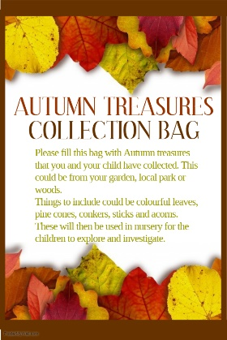
Autumn Collection Bags
We will be handing out Autumn collection bags from the
Foyer soon. Have fun collecting natural resources for us to
explore and enjoy in nursery.

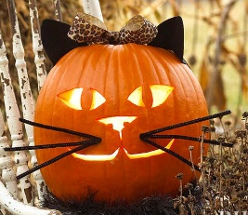
Halloween Pumpkin Competition
Get carving and be creative! A classic Halloween design, a princess, a gluey sticky masterpiece …..anything goes.
Your entries will go into our yearly competition with fun prizes to be won. This year we ask that you send us a photo of your designs either via email to hello@toddleinprivatenursery.com or via message on out nursery Facebook page. We will share all entries on our Facebook page and the likes received will determine our winners.

General Reminders
- Please ensure you lock ALL gates, both inside and outside of nursery to avoid any escapee children.
- Sickness and diarrhoea:
The Public Health guidelines state that the recommended incubation period is 48 hours from the last bout. Nursery policy states children will be sent home after 3 bouts of diarrhoea or 1 bout of sickness.
Please, please, please don’t hold this against us. We do understand it can be difficult, especially for working parents but it is our duty of care to follow these guidelines.
- Please note invoices are done a month in advance (generally in the last week of the previous month) and are located in individual room boxes on the shelf in the foyer. Payment is to be made no later than the 15th unless prior arrangements have been made in the office.

